Master Document — Team Page Mock Sprint
29-Garage (RMIT)-AI Assistant for HR Team 1

[Login Restyling Bootstrap] Task 1 —Write Requirements: Team Page & Login Styling
Role | BA — Scarlett. (s4007562) | Date | Wednesday, 12 August 2026
Completion comment
Done: Documented required fields for the team page (team name, project name, per-member photo/name/role, about-us blurb) and confirmed login work is styling-only, no auth logic changes.
Deliverable: Requirements document, committed to the team repo.
Note for next role: UX — we have 5 team members, one doesn't have a headshot yet, so the design needs a placeholder-avatar treatment. Two members also have longer blurbs, so don't assume a one-line blurb.

Git URL (doc): https://github.com/Minarsh1520/garage-boilerplate-basic/blob/main/docs/Mock%20Sprint%201/requirements.md

[Login Restyling Bootstrap] Task 2 — Design Login Style & Team Page Layout
Role | UX — Arman Gholami (s4039910) | Date | Thursday, 13 August 2026
Completion comment
Done: Produced mockups for the restyled login page and the team page layout, including the placeholder-avatar and long-blurb cases BA flagged.
Deliverable: Figma file, linked from the team repo.
Note for next role: BA — the handled edge cases are visible in the image file- mostly for the long texts, they just wrap into a new line / expand the card.

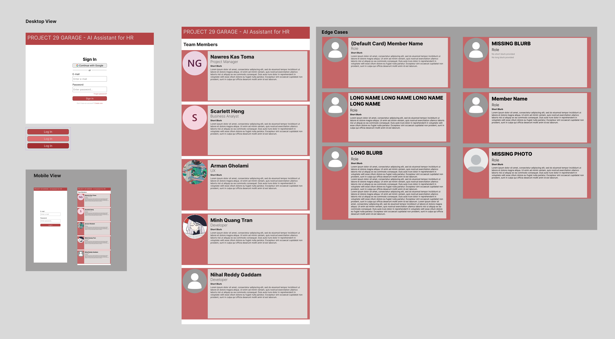
Figma Link: https://www.figma.com/design/zVycaCNODkbOOwfhTJ8Swk/Login-Teams-page?node-id=0-1&t=vvsZsnnZNtdoAHhq-1
Git URL: https://github.com/Minarsh1520/garage-boilerplate-basic/blob/main/docs/Mock%20Sprint%201/UX.md

[Login Restyling Bootstrap] Task 3 — Validate Design Against Requirements
Role | BA — Scarlett | Date | Thursday, 13 August 2026
Completion comment
Done: Checked both mockups against the requirements doc. All fields present, login scope stayed to styling only, placeholder-avatar and long-blurb cases both covered. Approved as-is, no changes requested.
Deliverable: Design validation sign-off, committed to the team repo.
Note for next role: Dev — you're clear to build exactly to the Figma file, no open questions from BA's side.
Git URL: https://github.com/Minarsh1520/garage-boilerplate-basic/blob/main/docs/Mock%20Sprint%201/design-validation.md

[Login Restyling Bootstrap] Task 4 — Style Login Page
Role | Dev 1 — Minh Tran | Date | Friday, 14 August 2026
Completion comment
Done: Applied the approved login styling (colors, layout, branding). Confirmed auth logic, validation, and session handling are all untouched.
Deliverable: Branch/commit with the styling changes.
Note for next role: Nothing blocking — moving straight on to the team page build myself.
Git URL (commit): https://github.com/Minarsh1520/garage-boilerplate-basic/commit/dc9ab2cecad6517caa089a42192488c9486eddcc
Git URL (doc): https://github.com/Minarsh1520/garage-boilerplate-basic/blob/main/docs/Mock%20Sprint%201/Restyling%20Sign%20In%20and%20Adding%20Team%20Page.md
REAL OUTPUT — rendered login page
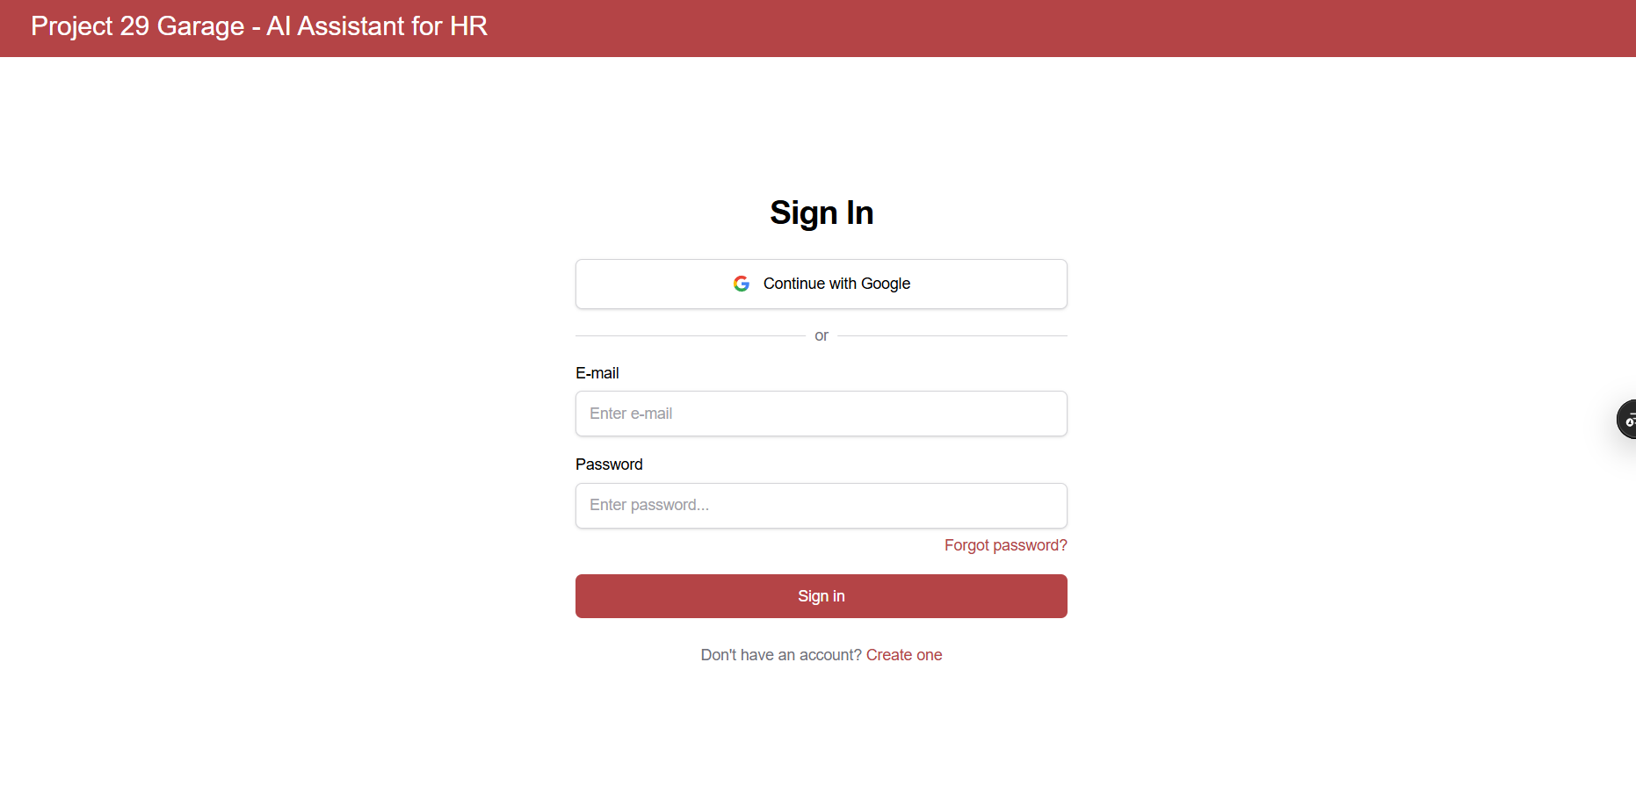

[Login Restyling Bootstrap] Task 5 — Build Team Page & Auth Redirect
Role | Dev 1 — Minh Tran | Date | Sat, 15 August 2026
Completion comment
Done: Team page built per the design (name, member cards with photo/role, about-us blurb with expand-on-long-text). Login now redirects here on success; team page redirects back to login if accessed directly without a session.
Deliverable: Branch/commit with the team page and route guard.
Note for next role:
- Dev 2 — please test against the deployed URL once it's live, not localhost.
- BA have so many name varieties, please pick one
Git URL (commit): https://github.com/Minarsh1520/garage-boilerplate-basic/commit/dc9ab2cecad6517caa089a42192488c9486eddcc
Git URL (doc): https://github.com/Minarsh1520/garage-boilerplate-basic/blob/main/docs/Mock%20Sprint%201/Restyling%20Sign%20In%20and%20Adding%20Team%20Page.md
"grid min-h-[clamp(8rem,6rem+8vw,14rem)] grid-cols-[clamp(7rem,5rem+8vw,13rem)_1fr]"
p-[clamp(1rem,0.75rem+1vw,2rem)]
text-[clamp(0.875rem,0.75rem+0.6vw,1.25rem)]
Note for future, scaling using clamp are much better
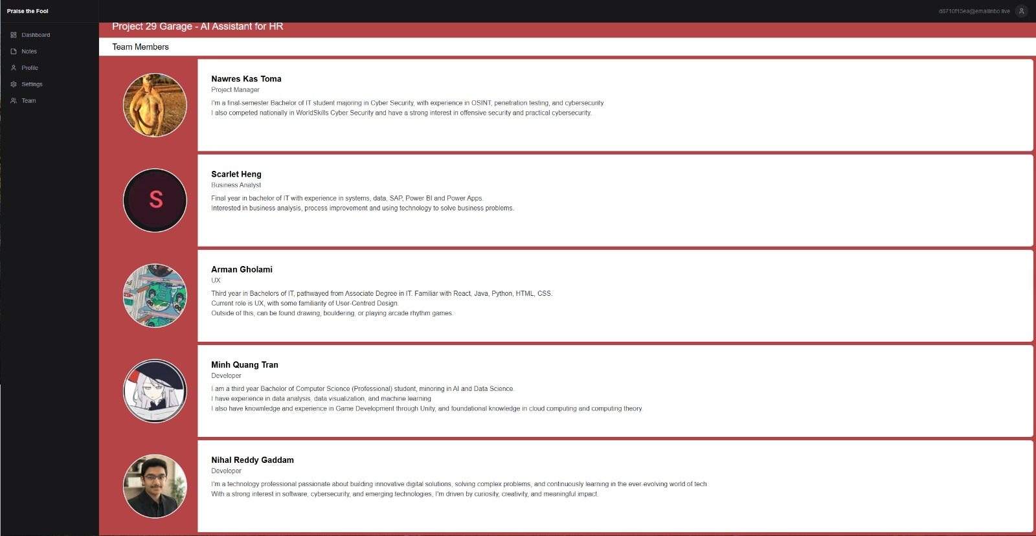

[Login Restyling Bootstrap] Task 6 — Test Login → Redirect → Team Page Flow
Role | Dev 2 — Nihal Reddy | Date | Sat, 15 August 2026
Completion comment
Done: Tested the full happy path on the deployed URL. Valid login worked, user redirected to Team Page, all member cards render correctly with photo/role/blurb, expand-on-long-text works.
Deliverable: Dev 2 Test script and test report.
Note for next role: No issues found on the happy path. Moving on to edge cases next.
Successful Login and redirection to Team Page:
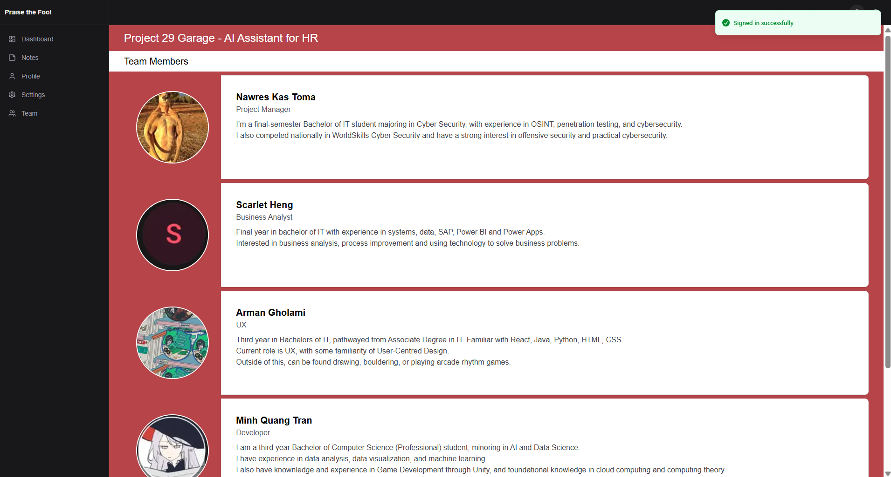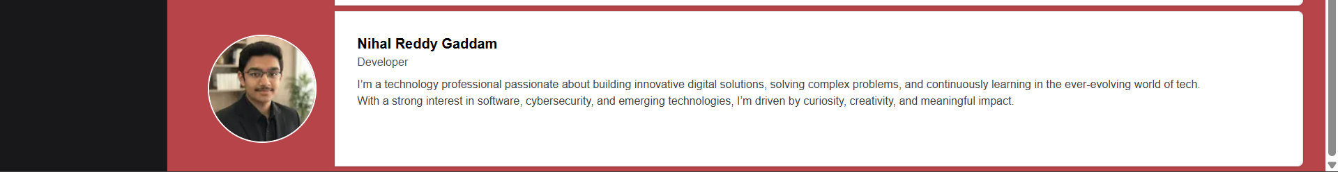
Git URL (doc): https://github.com/Minarsh1520/garage-boilerplate-basic/blob/main/docs/Mock%20Sprint%201/Login%20Page%20%26%20Team%20Page%20Test%20Report%20and%20Script.md

[Login Restyling Bootstrap] Task 7 — Test Edge Cases & Log Bugs
Role | Dev 2 — Nihal Reddy | Date | Sat, 15 August 2026
Completion comment
Done: Tested invalid login, direct team-page URL access without login, missing-photo member, and an unusually long blurb. No bugs found.
Deliverable: Edge case test report.
Note for next role: PM — everything passed, nothing outstanding for Dev 1 to fix before your review.
Git URL (doc): https://github.com/Minarsh1520/garage-boilerplate-basic/blob/main/docs/Mock%20Sprint%201/Edge-Case%20Test%20Report.md
[ IMAGE PLACEHOLDER — Invalid login error state screenshot — replace with actual screenshot ]
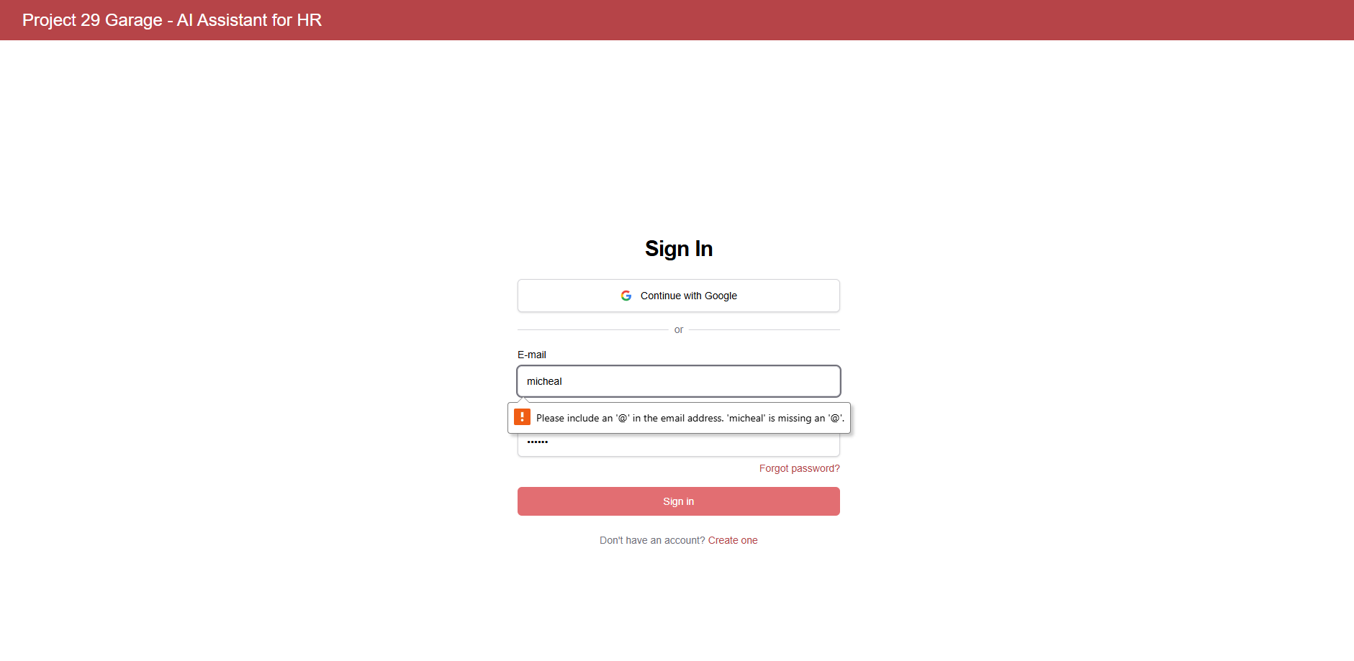Fig 1. Wrong Email Format
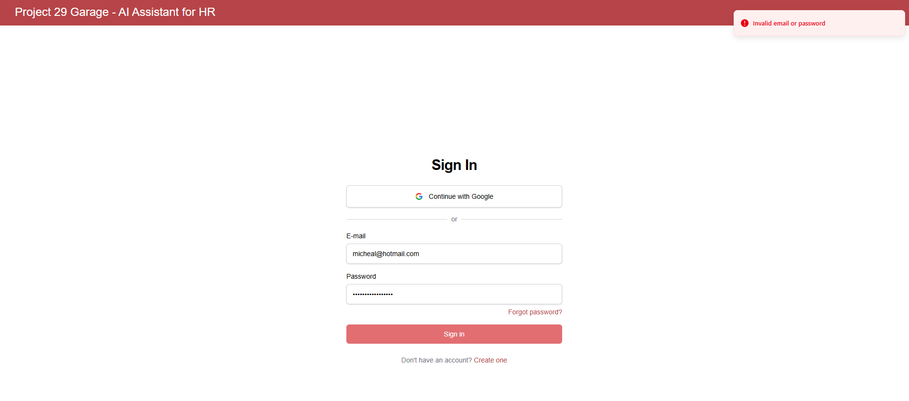Fig 2. Wrong Email or Password
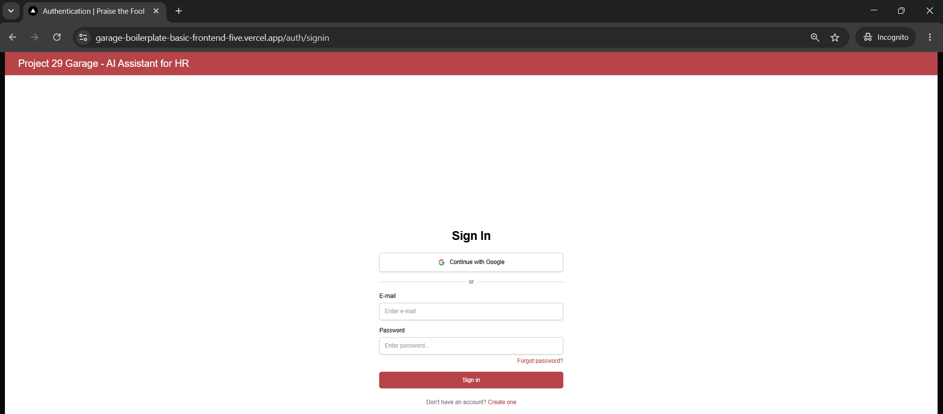Fig 3. Accessing /team page in incognito or without login redirects to log in and no access to team page

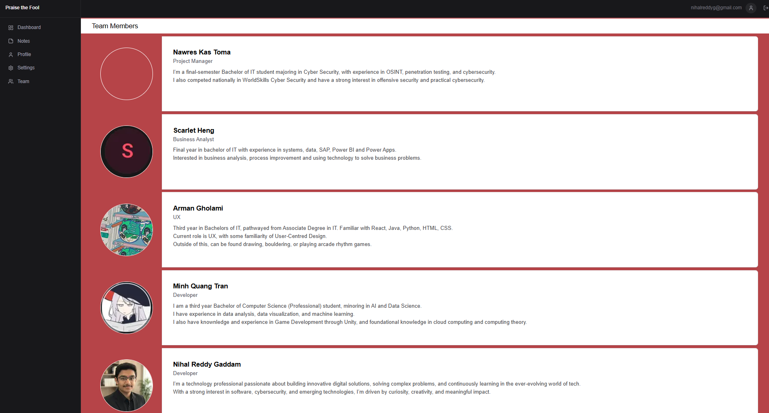Fig 4. Missing Photo and Long Blurb
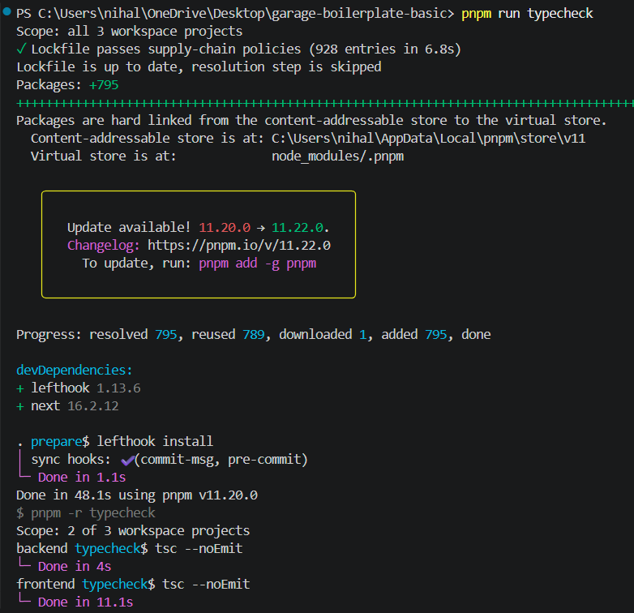
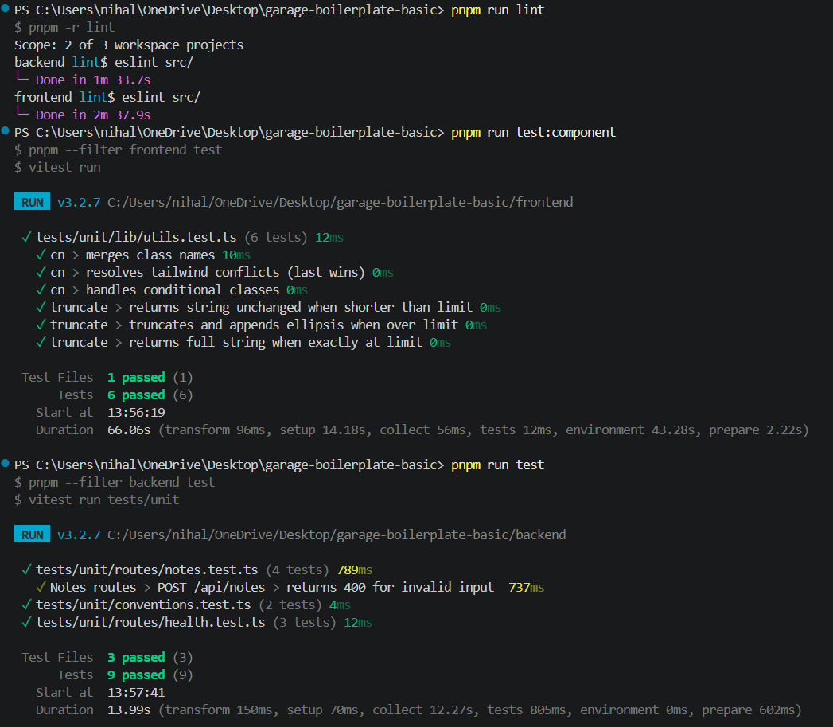

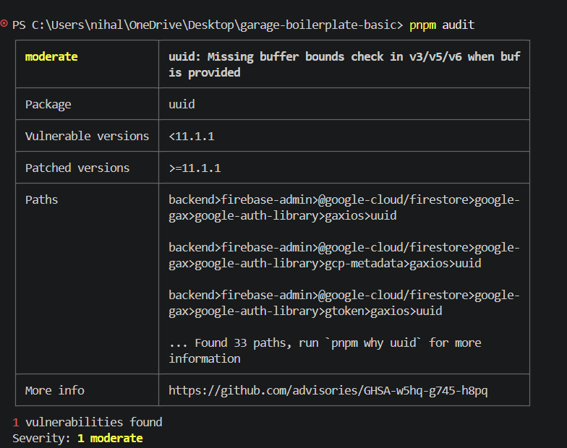
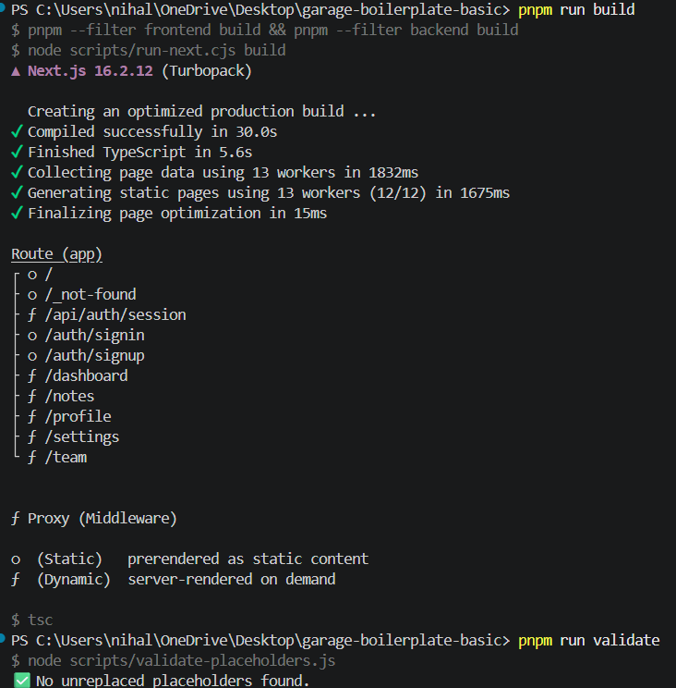

[Login Restyling Bootstrap] Task 8 — Final Review & Sign-Off
Role | PM — Nawres Kas Toma | Date | Sun, 16 August 2026
Completion comment
Done: Reviewed the feature end-to-end against the requirements and design. Verified every prior task's checklist and completion comment. Everything matches — approved.
Deliverable: Sign-off note.
Note for next role: None — feature complete, board closed out.
Git URL: https://github.com/Minarsh1520/garage-boilerplate-basic/blob/main/docs/Mock%20Sprint%201/PM_Sign_Off_Task2%201.md

Sprint 1 - Week 1: Use Case Research
Each task below covers one candidate HR/AI use case. The owners will research the topic and fill in the five fields below: Pain Point, Current Uses, Potential Opportunities, Risks/Downsides, and References. These will contribute to the “Initial AI/Automation Use Case Research” document and the consolidated findings document, which will be compiled by the PM prior to the client meeting.

Research: Employee Onboarding Assistant - BA
Role | BA — Scarlett. (s4007562) | Date | Sunday, 23 August 2026
Status: Complete
Done: Completed research on the Employee Onboarding Assistant use case, covering the pain point, current uses, potential opportunities, risks/downsides, and relevant references.
Deliverable: Completed Employee Onboarding Assistant research document.
Note for next role: PM research is complete, with nothing outstanding for review or follow-up.
Git URL (doc): https://github.com/Minarsh1520/garage-boilerplate-basic/blob/d2663a864ab2e20ce9a8656febb926ce40b552f0/docs/Sprint%201/BA-Spring1Week1-Research%20Employee%20onboarding%20(1).docx

Research: AI Interview Note-Taking Assistant - DEV
Role | Dev 2 — Nihal Reddy | Date | Sunday, 23 August 2026
Status: Complete
Done: Completed research on the AI Interview Note-Taking Assistant use case, covering the pain point, current uses, potential opportunities, risks/downsides, and relevant references.

Deliverable: Completed AI Interview Note-Taking Assistant research document.

Note for next role: PM research is complete, with nothing outstanding for review or follow-up.

Git URL: https://github.com/Minarsh1520/garage-boilerplate-basic/blob/docs/sprint-1/docs/Sprint%201/Dev2-Nihal-Sprint1-Research.docx

Research: HR / Policy Knowledge Assistant - UX
Role | UX — Arman Gholami (s4039910) | Date | Sunday, 23 August 2026
Status: Complete
Done: Completed research on the HR / Policy Knowledge Assistant use case, covering the pain point, current uses, potential opportunities, risks/downsides, and relevant references.
Deliverable: Completed HR / Policy Knowledge Assistant research document.
Note for next role: PM research is complete, with nothing outstanding for review or follow-up.

Git URL: https://github.com/Minarsh1520/garage-boilerplate-basic/blob/docs/sprint-1/docs/Sprint%201/UX-Sprint1Week1-Research.pdf

Research: HR Service Request & Routine Task Automation - DEV
Role | Dev 1 — Minh Tran | Date | Sunday, 23 August 2026
Status: Complete
Done: Completed research on HR Service Request & Routine Task Automation, covering the pain point, current uses, potential opportunities, risks/downsides, and relevant references.
Deliverable: Completed HR Service Request & Routine Task Automation research document.
Note for next role: PM research is complete, with nothing outstanding for review or follow-up.
Git URL: https://github.com/Minarsh1520/garage-boilerplate-basic/blob/docs/sprint-1/docs/Sprint%201/Dev1-Sprint1Week1-Research%20HR%20service%20requests.docx

Research: Recruitment & Candidate Admin - PM
Role | PM — Nawres Kas Toma | Date | Sunday, 23 August 2026
Status: Complete
Done: Completed research on the Recruitment & Candidate Admin use case, covering the pain point, current uses, potential opportunities, risks/downsides, and relevant references.
Deliverable: Completed Recruitment & Candidate Admin research document.
Note for next role: Client meeting / consolidated findings — research is complete, with nothing outstanding for review or follow-up.
Git URL: https://github.com/Minarsh1520/garage-boilerplate-basic/blob/docs/sprint-1/docs/Sprint%201/PM-Recruitment-Use%20case.docx

Sprint 1 - Week 2: Shortlist, Requirements & Prototype

Shortlist: Decide on 2 Use Cases - PM
Role | PM — Nawres Kas Toma | Date | Sun, 30 August 2026

Status: Complete
Done: All 5 Week 1 use cases were reviewed regarding value, feasibility and risk. A meeting was held with the team and the following 2 use cases were agreed upon as the final ones: HR Service Requests and Employee Onboarding. The reasons for this were discussed and agreed upon during the meeting rather than being made all by one person. The decision was then passed on to the team.
Deliverable: Team meeting decision, outcome logged in Planner and shared with team via message.

Create & Assign Tasks - PM
Status: Complete
Done: Tasks created for BA, UX and Dev according to the light plan. Tasks have been assigned with an owner, number of hours, a due date. Acceptance criteria has been created for each task and passed to Scarlett via the Notes on the task. All tasks are on the team board and are made visible to the entire team.
Deliverable: Fully populated Planner board with acceptance criteria attached to each task.
Note for next role: Scarlett - proceed with Gather Requirements task, using the acceptance criteria in the task Notes. Arman - UX Workshop follows once requirements are ready.
Git URL:

Gather Requirements (Employee Onboarding & HR Service Requests) - BA
Role | BA — Scarlett. (s4007562) | Date | Thursday, 3 September 2026

Status: Complete
Done: Initial business requirements were prepared for both Employee Onboarding and HR Service Requests. Following review and discussion with UX and PM, gaps and clarifications were identified and the requirements were amended. The final version includes more detailed and testable requirements, acceptance criteria, edge cases, MVP user journeys, scope and sample questions/requests.
Deliverables:
Initial BA Requirements Document (v1)
Amended/Final BA Requirements Document (v2)

Amendment Note: The initial requirements were reviewed with UX and PM during the meetings. Feedback from this review was incorporated into the amended version, which was then used by UX to develop the final prototype.

Note for next role: UX can use the approved requirements to develop and validate the prototype. Any gaps identified during UX design can be sent back to BA for clarification or amendment.
Git URL: V1-Git
Git URL:V2-GIT

UX Workshop + Bare Prototype - UX
Role | UX — Arman Gholami (s4039910) | Date | Friday, 4 September 2026

Status: Complete
Done: Workshop conducted with team. Team contribution resulted in a basic prototype being created. Both use cases (HR Service Requests and Employee Onboarding) had their main flows established.
Deliverable: Bare prototype covering key flows for both use cases.
Git URL: 20Prototype
Git URL: Figma Link

Implement Requirements into Prototype – UX
Role | UX — Arman Gholami (s4039910) | Date | Friday & Saturday, 4&5 September 2026

Status: Complete:

Done: Low fidelity prototypes have been created for both use cases: UC1 (Employee Onboarding) and UC2 (HR Service Requests). For UC1 the following paths are included: chat interface, checklist overview, AI response/escalation and human response. For UC2 the following paths are included: request status, request identification via chat, data collection and confirmation prior to request submission.

Deliverable: UC1 and UC2 low-fidelity prototype images, uploaded to Sprint 1 Week 2 Teams folder.

Git URL: 20Prototype
Git URL: Figma Link

Validate Prototype Against Requirements – BA
Role | BA — Scarlett. (s4007562) | Date | Saturday, 5 September 2026

Status: Complete
Done: BA requirements were checked for both UC1 and UC2. Both processes match the required scope and there are no significant differences that require updating. A few cosmetic improvements in the user experience were proposed (clicking on UC1 will show a more detailed checklist and for UC2 there is a confirmation that the request has been successfully submitted). These are all optional improvements and are not show stoppers.
Deliverable: BA sign-off: task completed and approved from BA.

Dev Research: Software, Frameworks & Bootstrapping (Employee Onboarding) - DEV
Role | Dev 1 — Minh Tran | Date | Friday, 4 September 2026

Status: Complete
Done: Researched software/frameworks for onboarding FAQ answering and request-status tracking. Recommended approach checks each option against the BA requirements directly: Vercel AI SDK for the chat/streaming layer, Firestore native vector search with the Genkit embeddings extension for retrieval (skipping LangChain/LlamaIndex, since the approved-document set is too small to justify the added complexity), and a Firestore status-enum + transition-map pattern for request tracking, reusing the existing useCollection hook for realtime updates. Escalation uses a tiered confidence threshold plus a hard-coded restricted-topic override, shared with the Service Requests use case. AI Canva repo reviewed. Cost/risk considerations documented (Firestore free-tier limits, per-token LLM billing).
Deliverable: Research document covering candidate frameworks/tools for the Onboarding use case, and a review of Alessio's AI Canva repository.
Git URL: [to be added once complete]

Dev Research: Software, Frameworks & Bootstrapping (HR Service Requests) - DEV

Role | Dev 2 — Nihal Reddy | Date | Saturday, 5 September 2026
Status: Complete
Done: Researched software/frameworks for HR Service Request classification and routing. Recommended a hybrid approach: an AI model classifies the employee's natural-language request into a predefined category (e.g. ADDRESS_CHANGE, PAYROLL_QUERY), using structured output rather than freeform text, while application logic (not the AI) determines the routing destination via a controlled routing map. This keeps routing predictable and testable, and ensures unsupported or sensitive requests are escalated to a human rather than auto-processed, directly matching the BA requirement. Flags an open item: exact HR routing destinations still need confirming with the client before implementation. AI Canva repo reviewed.
Deliverable: Research document covering candidate frameworks/tools for the Service Requests use case, and a review of Alessio's AI Canva repository.
Git URL: [to be added once complete]

Approve Documents – PM
Role | PM — Nawres Kas Toma | Date | Satursday, 5 September 2026

Status: In progress
Done: Final review of requirements and prototype for both use cases, pending completion.
Deliverable: Approved requirements and prototype; Master Document to be updated with outcomes.

